Report for consumo alto con posible rotura

1. Time Series Characterization
Mean consumption: 1057.6040609137056
Median consumption: 417.5
Std deviation: 1131.2975259396653
Minimum consumption: 174
Maximum consumption: 4872
95th percentile: 3332.0499999999984
Total records: 394
Above Normal deviations: 12
Below Normal deviations: 0

2. Consumption Line Plot
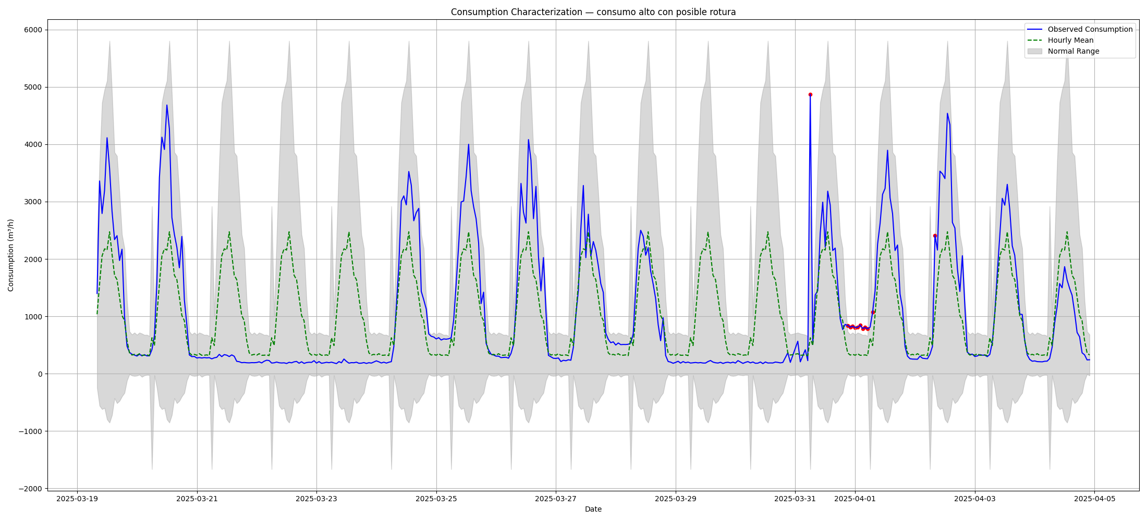

3. Deviation Heatmap
